PACIFYING THE MOJAVE MAKES ME WISH FOR A NUCLEAR WINTER
COMMITTEE BACKGROUND GUIDE

ENMUNC III

November 5th –6th 2022
Emory University
CRISIS DIRECTOR: Lanz Jabez Victoria
Table of Contents

Welcome Letter 2

Conduct Expectations 4

Committee Structure and Powers 5

Background and Lore 7

Factions Guide 15

Current State of Affairs 20

Characters/Positions 21

Welcome Letter

Dear Delegates,

My name is Lanz Jabez Victoria, and I am thrilled to be serving as your Crisis Director for Pacifying the Mojave Almost Makes me Wish for a Nuclear Winter! Not only am I thrilled to be serving as a CD for the first time, but I am excited to see all the plots and perspectives that you bring to the committee for our first in-person Emory High School Model UN Conference.
As a third-year student majoring in Political Science, I’ve found that Model UN is a place in which I could engage in my interests regarding real-world international relations, disputes in fictional settings, and general debate! I come from a small island in the Pacific Ocean, and there was no Model UN presence in my high school days whatsoever, thus my first experience with Model UN was at the collegiate level. Interestingly, the only type of committee that I’ve engaged in at MUN was crisis, though I find that it is perhaps the most intriguing and dynamic form of debate competition out there! Crisis committees enable delegates to engage in debate and discussion at a very personal level, and the possibilities in terms of setting and background are infinite.
This committee will be centered around the events of the 2010 action role-playing video game Fallout: New Vegas. Fallout is a game series that I hold near and dear to my heart, as I’ve found myself drawn into its expansive lore and thought-provoking themes. When establishing this committee, I hoped that some of the delegates would share my fondness of this game series (though if you’re not familiar with the game, no worries!)
The lore of Fallout: New Vegas presents countless possibilities for character development within a crisis committee, and I invite you all to go wild with your character and crisis arcs both in-room and in the backroom! Throughout the committee, you all will have the chance to engage in politicking similar to that which is done in the real world, yet in the unique setting of a post-nuclear United States. You all will be dealing with a variety of challenges surrounding the running of the city of New Vegas, and will carry out actions for the purpose of increasing both your character’s and faction’s power. Consequently, these actions will lend themselves to a competitive spirit in-room (which is great!), though I expect respectful attitudes and language between delegates at all times.
I look forward to working with you all, and I’m excited to see what you guys come up with in committee!
Sincerely,

Lanz Jabez Victoria
lcvicto@emory.edu

Expectations for Conduct

Model United Nations is about learning about the world around us and about gaining a better understanding of the communities and cultures we interact with. This activity is built on mutual respect, understanding, and empathy. Treating your fellow delegates with respect inside and outside of committee sessions is the most important way to ensure that we all have the most fun in committee. We want to cultivate a competitive environment that leaves all delegates invigorated, not depressed or unfulfilled. We strongly believe that competitive success comes from well-executed speeches, arcs, and research rather than from undermining or denigrating others. As such, we will not reward duplicitous behavior and will instead encourage you to cooperate and lift your fellow delegates’ voices.
Fallout: New Vegas deals with a number of topics that are both controversial and potentially triggering. Thus, we will take every measure necessary and possible to limit the presence of these topics in-committee. We have a zero-tolerance policy for racism, sexism, homophobia, and any other forms of intolerance or harassment. Do not use any form of intolerance as a character motivation; accuracy to lore will not be taken as an excuse. Delegates can talk to any of us if something occurs in or outside the committee that makes them uncomfortable. In addition, reporting mechanisms will be in place during the committee (such as through anonymous feedback forms); we won’t hesitate to shut down behavior that we deem to be inappropriate.
One example I’d like to highlight is the faction of Caesar’s Legion. Devoted followers of the Fallout franchise will know that one of the central tenets of this faction’s culture is misogyny—women are actively discriminated against and denigrated within the game’s depiction of this faction. I cannot stress the following enough: in no way, shape, nor form will this aspect of the faction, nor any other that violates the above zero-tolerance policy, be present in the committee. In a way, this committee is not 100% faithful to the source material, and we will remove or leave out parts of the lore that may lead to violations of our policy.
Lastly, as this is an in-person committee, it’s important to remember that you will be guests on Emory’s campus. Thus, I expect an attitude of respect towards the facilities that the University has lended us. Furthermore, please keep in mind both city and university policies towards COVID-19 as we continue to brave this pandemic.

Committee Structure and Powers

Committee Structure
Pacifying the Mojave Makes Me Wish for a Nuclear Winter (Pacifying the Mojave for short) is centered around a council of representatives from the factions present around the city of New Vegas. The committee will run for a period of eight years from the year 2282 to 2290, and will feature disputes over control of the city and surrounding Mojave wasteland.
The committee is (in-lore) chaired by Yes Man, the robot right hand man of the Courier, the former leader of New Vegas. This committee will make binding decisions that directly affect New Vegas as they will be implemented by Yes Man and the existing government infrastructure of the New Vegas area. The advisory council will be able to implement both short-term and long-term policies with a simple majority vote, which will have time to take effect, as this committee will take place over a decade. Yes Man has drawn together distinguished figures from various factions and communities in the Mojave Wasteland, from both major and minor factions, as well as representatives of certain sub-factions within the major factions. Although not all members of the committee hold official titles or faction roles, they all have the same voting power. Each member has been given a unique role to contribute to the committee while pursuing their own agenda in the backroom.
The committee takes place in the immediate aftermath of a war between the New California Republic and Caesar’s Legion over control of the area, in which a third-party faction led by the elusive Courier intervened to prevent either side from taking control. Prior to the committee’s formation, the Courier mysteriously disappeared, and the delegates will have to negotiate over the fate of the city, as well as solidifying their respective factions’ power.
As a representative of a faction, you will have control over specific resources or subordinate groups to carry out actions through crisis notes; characters may also have specific expertise regarding governance of the city. Crisis arcs should be planned to achieve a desired outcome in the world; your ultimate objective is to increase your character’s or faction’s power.
With regards to crisis updates, I will periodically be subjecting the committee to events with effects on both individual characters’ power and the world at large. These crisis updates will reflect both my own vision for the committee as well as the outcomes of collective in-room decisions and directives. Remember that our staffers have the ultimate say on the effects of your crisis arcs, preference will be given to those who give the most detailed, logical, and lore-friendly backing to their actions.

Committee Logistics
This is a crisis committee with traditional Model UN parliamentary procedure. This committee will utilize a dual notepad system, and to maximize the efficiency of communication between the crisis staffers and delegates, I highly encourage you to write clearly and succinctly, with no more than a page at a time. Delegates should feel free to pass notes around to each other (especially at times when cross-talk is prohibited), and will also be drafting, signing, and sponsoring directives on paper. Google docs will be used to type up directives that go to the voting floor, and delegates will vote by simply raising their placards when voting is called. Lastly, the dress code in-committee is Western Business attire, though if you have any plans for dressing in a Fallout-related outfit or costume, please email in advance to clear it with me first!

Background and Lore

The Pre-War United States
The Fallout universe’s point of divergence from our own was in 1945, when the United States dropped the atomic bomb on Hiroshima. Following that point, the United States (and the world generally) followed a path of societal, cultural, and technological development strikingly different from our own. For instance, most of the cultural attributes of the Fallout universe seem stuck in the period of the 1950s-1960s. Jazz and big band music remains prominent, whereas clothing styles align very closely with those of the 1950s.
Perhaps the biggest change from our own world was in the path of technological development in the Fallout universe. In the Fallout universe, the transistor was never developed in 1947, putting technological development down a very different trajectory. For instance, technological devices were never developed in a course of minimization in the way that they were in our world. Personal computers were never invented, nor the internet, and much of the world’s technology seemed stuck in a quasi-1940s state of vacuum tubes and black and white displays. Nonetheless, technological development persisted, and by the mid-21st century, innovations such as nuclear-powered personal vehicles and household robots were commonplace. By the year 2077, advancements in military technology had progressed to unforeseen heights; technologies such as Power Armor (heavy armor suits supported by exoskeletons) and laser weapons began being implemented in the armed forces.
Societally speaking, the world of Fallout remained in a state of Cold War tensions. However, by the 1990s, the primary rival of the United States shifted from the Soviet Union to the People’s Republic of China, and American society remained firmly anti-communist. Nonetheless, by the 21st century, racial tensions had also become alleviated, with the American people relatively united against the common threat of communist ideology.

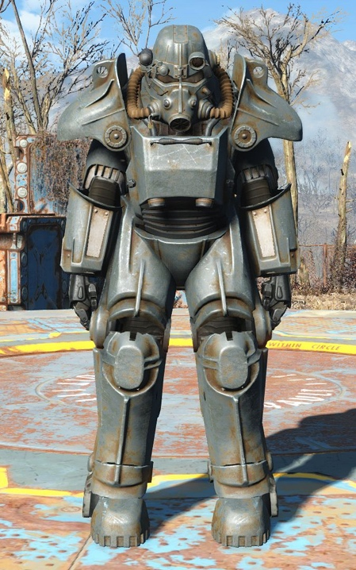

Around the mid-21st century, the world had begun to run out of fossil fuels. This led to increased competition for resources between the nations of the world, with organizations such as the European Union and United Nations dissolving due to their inability to prevent conflict. In 2066, China declared war on the United States, seeking access to both the last remaining American oil reserves in Alaska as well as American innovations in fusion cell technology. This led to a Chinese invasion of Alaska, which in turn resulted in the American annexation of Canada for easier access to Canadian resources. With the introduction of advanced power armor into frontline units in 2076, the United States was able to turn the tide of the war, and started pushing back the Chinese forces, eventually even landing troops on mainland China.
The heating-up of conflict led to the initiation of Project Safehouse in 2054, a Federal program intended towards the creation of a network of nuclear bunkers across the country. The enigmatic Vault-Tec corporation won the contract for the construction of these bunkers, known as Vaults, which were meant to preserve at least a portion of the American population for rebuilding after a nuclear war.
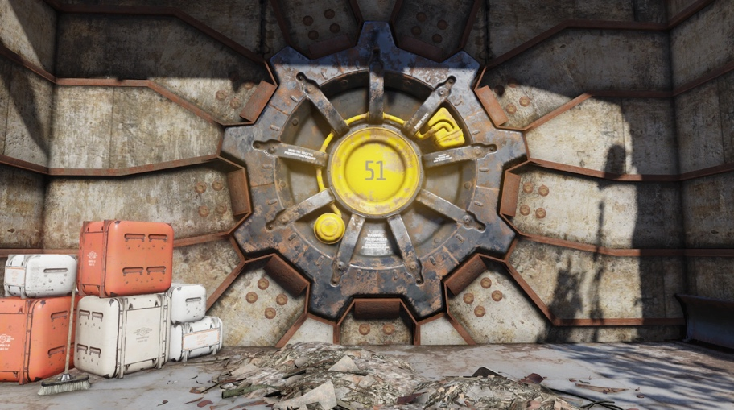

The Great War
On October 23rd, 2077, Mutually Assured Destruction was proven to be true, and the Great War began with the exchange of nuclear weapons by multiple nations around the world. To this day, nobody knows who first pushed the button ending the world.
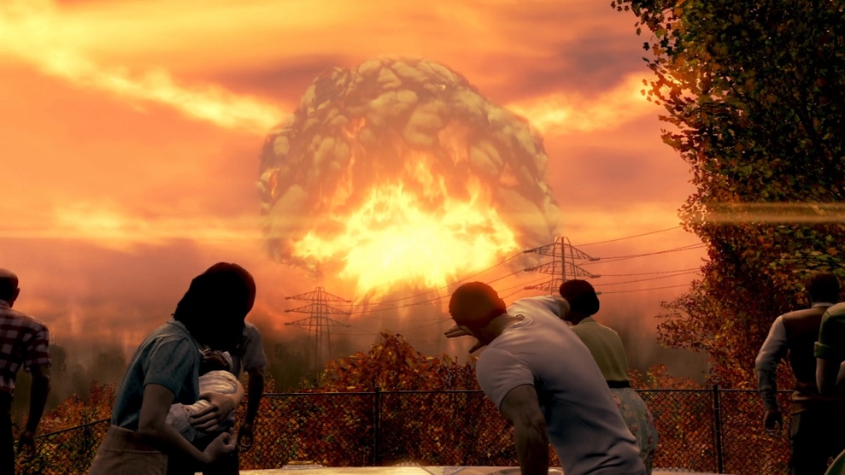
The atom bombs wiped out civilization, and killed a majority of the world’s population; owing to the blasts, or the radiation and starvation that followed, the United States ceased to exist. Minor pockets of individuals managed to survive the Great War, by staying in basements or private shelters, fleeing to isolated wilderness, or by simply residing in non-targeted areas.
The Vaults were opened once the nukes were detected, and their populations were rushed to the bunkers to wait out the nuclear storm. However, Vault–Tec only managed to build around 200 Vaults before the war began, and with a maximum vault capacity of 1000 individuals, barely a fraction of a percentage of the American population was able to enter the Vaults. Furthermore, Vault-Tec had an ulterior motive for making the Vaults—using these isolated pockets of civilization as labs for social, biological, and chemical experimentation.
The radiation released by the blast resulted in widespread mutations among the surviving animal and plant life. Many animals, such as cows, sheep, and bears, became mutated by the radiation, becoming stronger, or growing two heads. Humans, too, were not free from mutation, with a significant number of survivors turning into ghouls, human beings stripped of their hair and flesh by the radiation, with incredibly long lifespans and susceptibility to insanity.

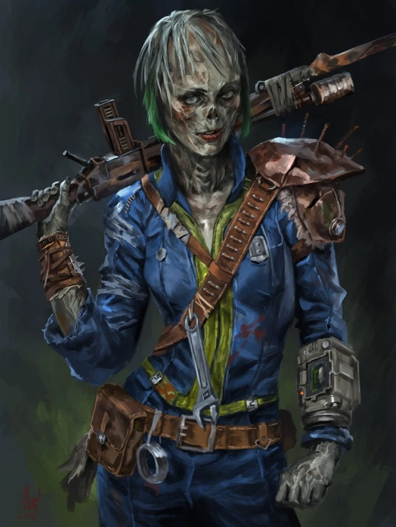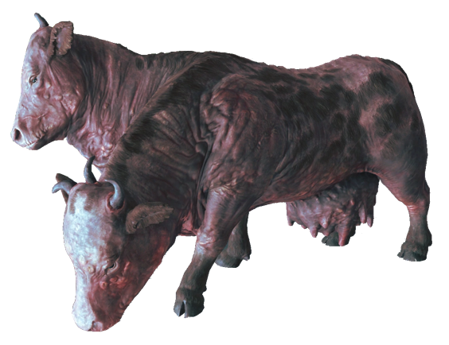

The Post-War American West
The Post-war American West is the setting for the first two Fallout games, as well as Fallout: New Vegas. In the immediate aftermath of the Great War, the Vaults in this area opened, with their populations starting settlements and tribes. From Vault 15 near Bakersfield, California, came a number of tribes, with the most notable one being the village of Shady Sands. The inhabitants of Shady Sands eventually formed the New California Republic (NCR), which grew to become a beacon of civilization in the American Wasteland. The NCR developed infrastructure and democratic institutions evocative of those of the pre-war United States, yet also had a penchant for expansion, incorporating settlements into its borders with little regard for the desires of its inhabitants.
Concurrently with the rise of the NCR came the formation of the Unity in the Boneyard (post-war Los Angeles). A group headed by the Master, a merchant who came into contact with the Forced Evolutionary Virus (FEV), a bioweapon developed before the war, which had the effect of increasing the physical size and strength of those subjected to it, while also diminishing their intelligence. The Master created an army of FEV Super Mutants, with the goal of eliminating non-mutated humanity, though was ultimately foiled by a mysterious vault dweller, his soldiers scattered across the wastes.

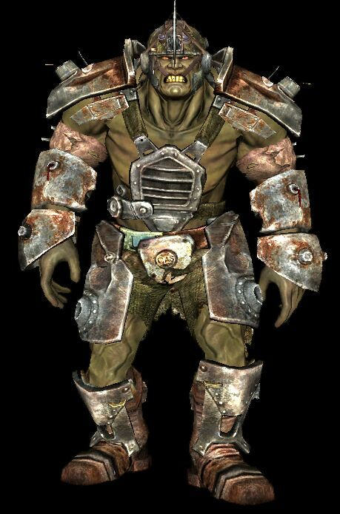

Another faction that arose in the American Wastes was Caesar’s Legion, founded by a cultural anthropologist and linguist from the NCR who traveled to the tribal lands in Arizona. While there, he united the tribes into a vicious organization modeled after ancient Rome, forcibly conquering much of the land east of the Colorado River under his banners.
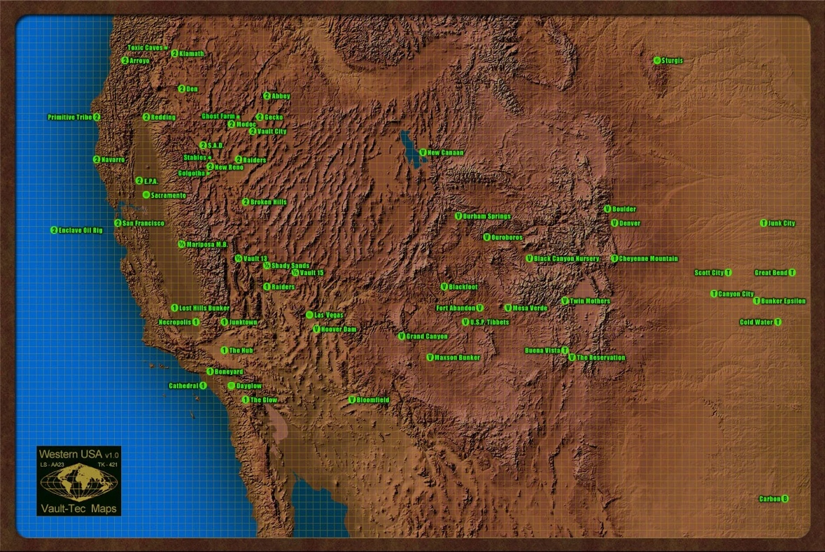

The Mojave Wasteland
The Mojave Wasteland is the area under dispute in this committee, with the city of New Vegas being its primary population center. The Mojave Wasteland was largely spared from the nuclear blasts, as it was the headquarters of the RobCo corporation, whose CEO Robert House installed anti-missile defense systems. After the nuclear war, this area devolved into anarchy, with raider gangs and savage tribes coming to inhabit the abandoned ruins of Las Vegas. Mr. House had been put into a coma following the war, only reawakening 60 years afterwards to unite the city’s tribes and restore civilization to Las Vegas.

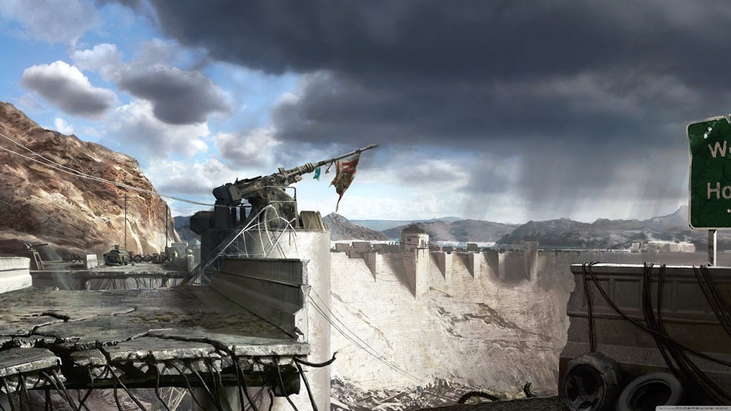
The Mojave Wasteland was of much importance to NCR and Caesar’s Legion, owing to its treasure trove of well-preserved technology and the mostly-intact Hoover Dam power plant. Both powers sent scouts and emissaries into the area, negotiating with Mr. House and the various groups in the area. By the year 2277, the NCR and Caesar’s Legion came to blows at the First Battle of Hoover Dam, wherein the NCR forces managed to push the bulk of Caesar’s troops across the Colorado River.
New Vegas managed to benefit greatly from the presence of the NCR, revitalizing its gambling and entertainment industries by catering to NCR tourists. Yet, conflict had not completely ended between the NCR and Caesar’s Legion, with them coming to blows again in the Second Battle of Hoover Dam in 2282.

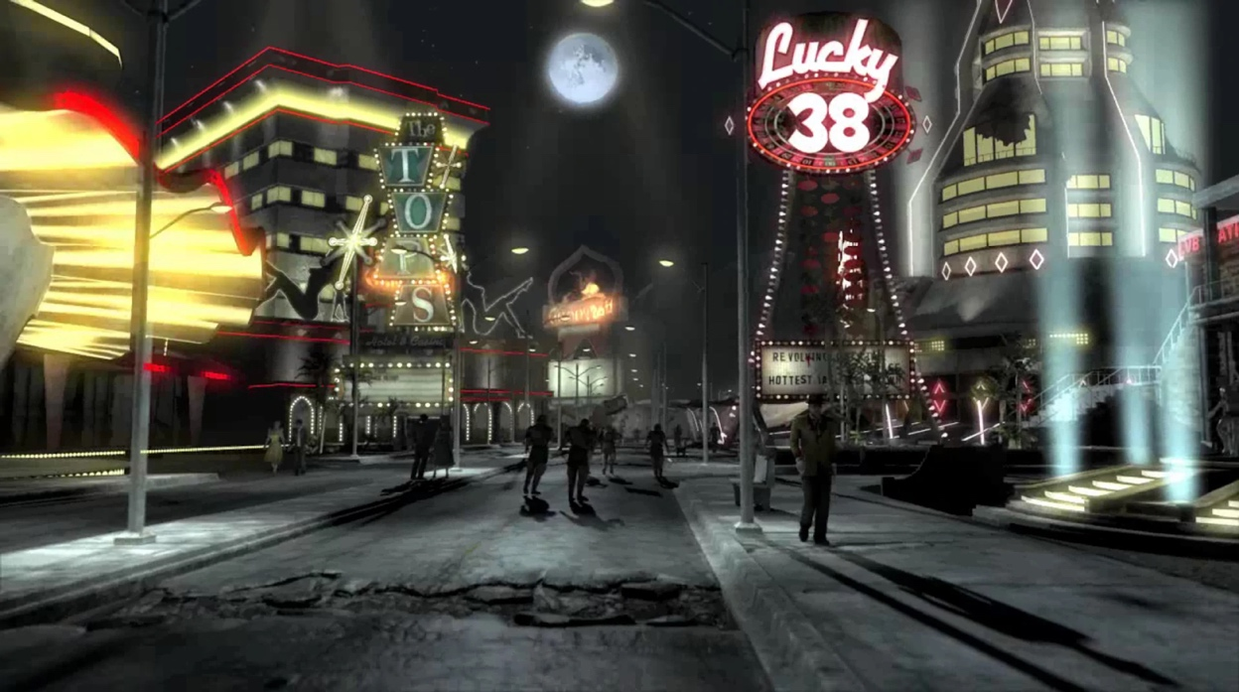

In the months prior to the Second Battle of Hoover Dam, an individual known as the Courier managed to overthrow Mr. House, and seized control of New Vegas. The Courier united a number of factions in the area, and intervened in the battle, forcing both the NCR and Legion to a cessation of hostilities. The Courier declared New Vegas an independent state, and forced both the Legion and the NCR out of the New Vegas strip and Hoover Dam. Yet, following his declaration, the Courier mysteriously disappeared, leaving the city leaderless, and throwing the area into disarray…
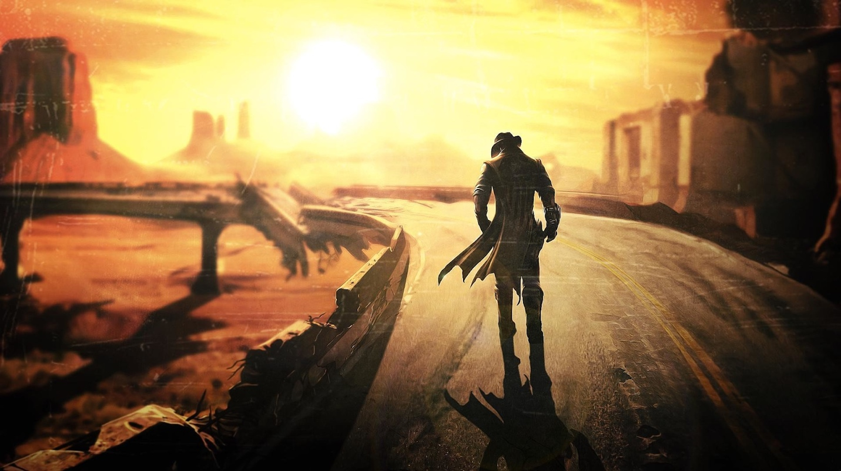

Major Factions Guide
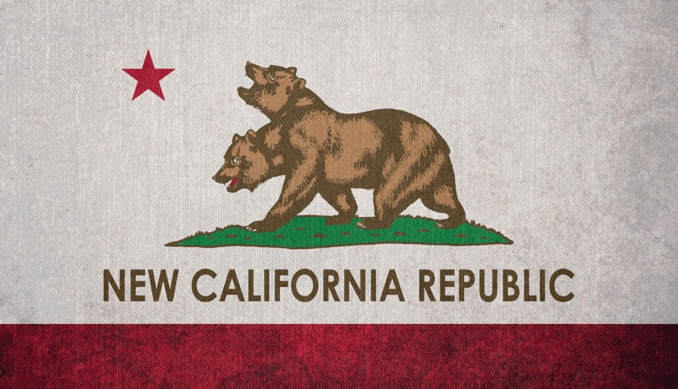

The New California Republic
The New California Republic is a democratic nation composed of the states of Shady Sands, Los Angeles, the Hub, Maxon, and Dayglow. It also maintains control of a number of locations not incorporated as full member states into the union (such as parts of Baja California and the Mojave). The NCR is a representative republic, with a president (currently Aaron Kimball) and Congress of representatives from each state. It is a well-developed country (by post-apocalyptic standards), with a strong agricultural and manufacturing sector, technological development, and utilities infrastructure. The NCR’s ideology is (at least officially) societal progress; it prohibits discrimination on the basis of gender, sexuality, ethnicity, religion, and even mutant status, with women being healthily represented at the upper echelons of government and mutants freely serving in its armed forces.
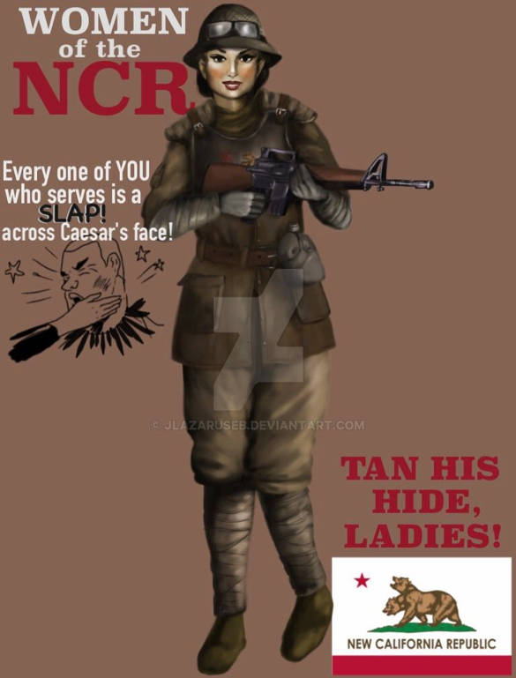
The NCR has a number of sub-factions present in the Mojave Wasteland, with the following being most prominent:
The NCR Army is the main defense force of the NCR, being composed mainly of conscripted soldiers, and is armed and armored with standardized equipment manufactured in NCR factories.
The NCR Rangers is a separate entity from the regular army, and was formed from a militia dedicated towards the abolition of slavery in California. They have developed into the premier special forces organization of the NCR, and are among the most professional and deadly forces in the West.
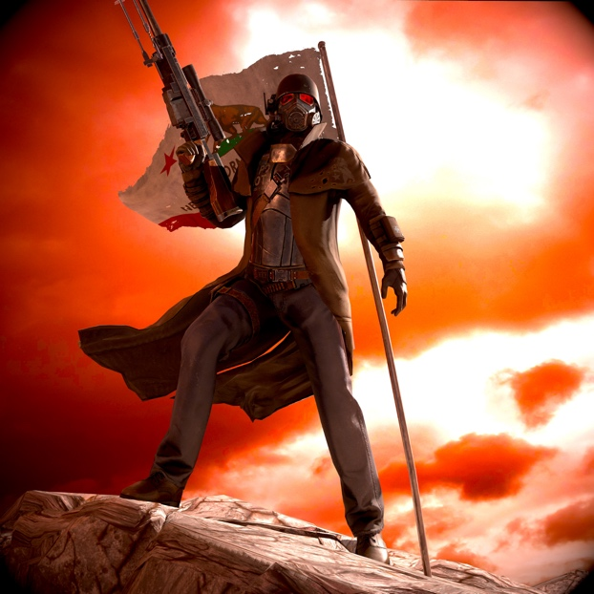
The NCR Embassy in New Vegas is the government’s representative in the Mojave Wasteland, officially having control over all NCR resources and personnel in the area.
The Brahmin Barons is a powerful political organization in the NCR, made up of wealthy ranchers who seek to expand their land holdings to the Mojave Wasteland.
Caesar’s Legion
Caesar’s Legion is a totalitarian dictatorship founded in 2247 by Edward Sallow (Caesar), a former NCR citizen, built on the conquest and enslavement of tribal societies in the American Southwest. To enforce unity in the absence of any civilian institutions, the Legion loosely models itself after the military of the Roman Empire, repurposing its language and aesthetics for the post-apocalypse.
As of 2282, the Legion controls large amounts of territory east of the Colorado River, primarily in the former states of Arizona and New Mexico, with footholds in Utah and Colorado. Worshiped as the "son of Mars" by his followers, Caesar's ultimate goal is to conquer the New California Republic and New Vegas to merge its civil institutions and infrastructure with the military strength of the Legion, creating a new totalitarian empire.
The Legion is structured in a strict hierarchy, with the leaders at the top, warriors (known as legionaries) at the middle, and slaves at the very bottom. At its core, the Legion is a slave army, and though it controls much land, it effectively allows many of those living under its banner autonomy, as long as they pay taxes. Although the Legion is infamous for its brutality, it has been praised by many of those living under its control, as it eliminated much of the anarchy in the Southwest.
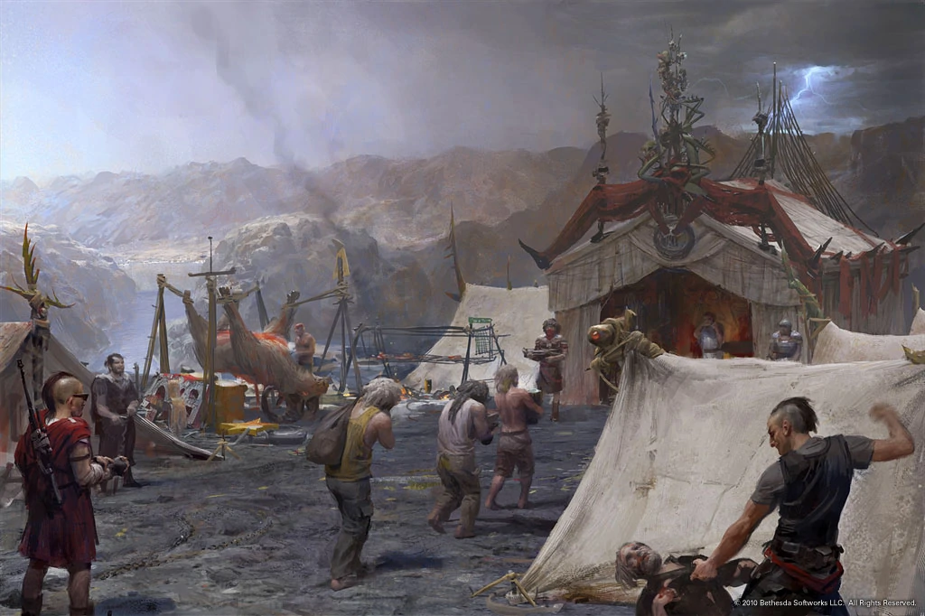
Ideologically speaking, the Legion believes in totalitarianism as the only way to preserve humanity in the post-apocalypse, espousing the belief that democracies (such as the NCR) are weak. Thus, obedience and strength are virtues in the Legion, with warriors being able to rise in the ranks through victory in battle.
[As a side note: in-lore the Legion features the strict segregation of the sexes, with only men being allowed to function as warriors, while all females are slaves to the warriors. In this committee, that aspect of the Legion is not present, essentially, men and women are equally able to serve as warriors in the Legion.]
Traditionally, the Legion is governed by Caesar, with a number of advisors around him from various sub-factions. However, following Caesar’s untimely death from a brain tumor immediately following the Second Battle of Hoover Dam, the Legion is officially under the control of his right-hand-man Legate Lanius, though not all accept his control…
Some sub-factions of the Legion are:
Lanius’s Cohort is the fighting force of which the majority of the Legion’s forces in the Mojave is part of. The fighters in this group pledge personal allegiance to Legate Lanius.
The Frumentarii is the espionage and subversion branch of the Legion. They are under the control of Vulpes Inculta, and are masters of disguise and guerilla warfare.
The Praetorian Guard is the personal guard of Caesar, and is led by Lucius. They are among the most deadly warriors in the Legion.
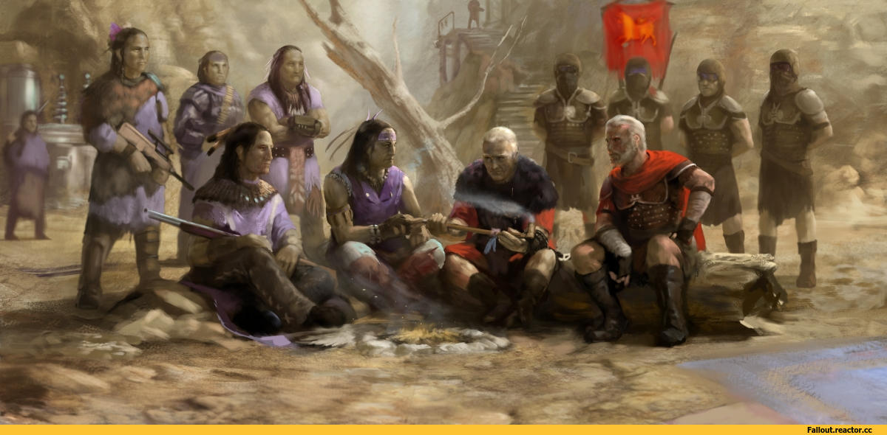

Current State of Affairs

Following the disappearance of the Courier, New Vegas has been left in disarray. The Courier’s advisor, the robot Yes Man, has invited delegates from the factions present in the Mojave to discuss the fate of the city. The representatives must deal with issues ranging from health (food, water, and medicine distribution) to widespread banditry. There must also be discussion over the present state of New Vegas; will it preserve its independence under new leadership, or will it cede autonomy to one of the major factions. Furthermore, control of resources in the Mojave is of paramount importance, there are treasure troves of abandoned technology in specific locations around the Mojave. The issue of ownership of power plants, such as the Hoover Dam and Helios One solar power plant, may also lead to another outbreak of violence. Lastly, the delegates must keep in mind that, although New Vegas is currently leaderless, there is much infrastructure and resources currently under the aegis of Yes Man, such as Mr. House’s army of Securitron robots as well as power lines and water pipes.
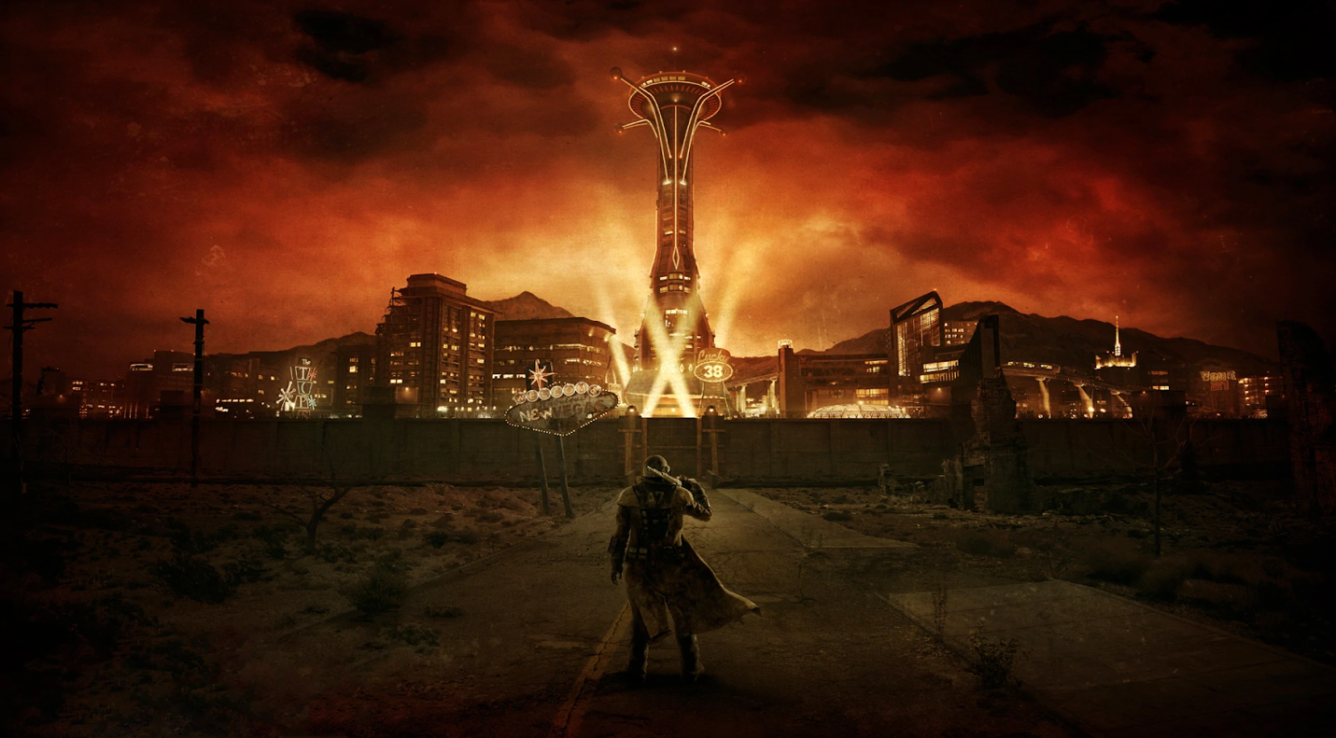

Characters/Positions

NCR Government: Ambassador Dennis Crocker
Ambassador Crocker is the NCR government’s official ambassador to New Vegas, and is a career politician. He has strong political ties to the current NCR president, Aaron Kimball, and is a strong believer in diplomacy, seeking to find a peaceful resolution to the issue of NCR influence in the region.

NCR Army: General Lee Oliver
General Oliver is a career soldier, and the commander of NCR military forces in the Mojave Wasteland. He is an outspoken supporter of President Kimball’s policy of eastward expansion into Nevada, and has no qualms with using force to expand NCR power (even at the unnecessary expense of NCR men and materiel). He has a grudge against Ranger Chief Hanlon, due to Hanlon’s strategic ingenuity outshining his own during the First Battle of Hoover Dam.

NCR Rangers: Chief Hanlon
Chief Hanlon is the head of the NCR Rangers, and one of its longest-serving members. He is known as a tactical and strategic genius, and has led NCR forces to victory over its foes in many battles. He is also, however, an opponent of eastward NCR expansion and has come to the conclusion that extending the NCR’s control over the Mojave would lead to the unnecessary loss of lives of both NCR soldiers and Mojave residents.

Brahmin Barons: Senator Heck Gunderson
Heck Gunderson is an NCR senator, and is also the head of the Central Valley Ranchers Association, a large cabal of brahmin ranchers that works to further their interests in the NCR government. He is determined to preserve the dominance of the Brahmin ranchers over the economy and politics of the NCR, and seeks to expand their operations into the Mojave.
Lanius’s Cohort: Legate Lanius
Legate Lanius is the commander of Caesar’s troops in the Mojave, and after Caesar’s death from assassination, became the leader of the Legion. He is a savage and brutal warrior, who believes in an ideology of war being the crucible in which the weak are consumed as fuel for the mighty to rise to greatness–he has no regard for diplomacy or subversion, only combat. However, he has his reservations about Caesar’s quest to conquer New Vegas, believing the Legion to be inadequate at truly holding the Mojave.

Frumentarii: Vulpes Inculta
Vulpes Inculta is the leader of the Frumentarii, an organization that engages in acts of espionage and deceit to further the Legion’s goals. He is a master of disguise and is an avid follower of Caesar’s ideology, seeking to purge the Mojave of what he views as “Californian debauchery”. His subversive methods put him at odds with Lanius, however, who views his tactics as weak and vile.

Praetorian Guard: Lucius
Lucius is the commander of the Praetorian Guard, Caesar's personal bodyguard, and is a devoted follower of Caesar’s ideology. Following Caesar’s death, Lucius vowed to continue his mission to expand the Legion into the Mojave and fulfill his master’s dream.

Boomers: Pearl
Pearl is the leader of the Boomers, an isolated tribe of former Vault Dwellers armed to the teeth with artillery and heavy weapons. She believes in ending the isolation of the Boomers and connecting with the outside world in order to ensure the survival of her tribe.

Brotherhood of Steel: Elder Nolan Mcnamara
Elder McNamara is the head of the Mojave chapter of the Brotherhood of Steel, an organization that seeks to preserve technology and keep it from falling into the wrong hands. He has put the Brotherhood under lockdown following a conflict with the NCR, yet is open to reopening relations with the outside world.

Followers of the Apocalypse: Julie Farkas
Julie Farkas is the leader of the New Vegas branch of the Followers of the Apocalypse, a humanitarian organization that seeks to rebuild the wasteland and reeducate its inhabitants. She currently has her hands full with providing food and medical care to the dwellers of the Mojave wasteland.

Great Khans: Papa Khan
Papa Khan is the chief of the Great Khans, a tribe of former raiders that fought a bloody war against the NCR. He seeks to revitalize his tribe by removing them from under the thumb of the NCR and returning them to their nomadic past.

Enclave Remnants: Judah Kreger
Judah Kreger is a former captain of the Enclave, an organization that was a remnant of the pre-war American government. Owing to his organization’s sordid past of kidnapping and human testing, him and his fellow Enclave remnants are wanted by the NCR, and only left hiding in order to support the Courier during the Second Battle of Hoover Dam.

Chairmen: Swank
Swank is the leader of the Chairmen, a former tribe that was civilized by Mr. House and given control over the Tops Hotel and Casino, one of the three remaining casinos on the Strip. He followed in the footsteps of his former boss, Benny, who sought to overthrow Mr. House by taking control of his Securitron Army.

Omertas: Nero
Nero is the leader of the Omertas, a former tribe that was civilized by Mr. House and given control of the Gomorrah Hotel and Casino. He sought to make an alliance with Caesar’s Legion in the run-up to the Second Battle of Hoover Dam.

White Glove Society: Marjorie
Marjorie is the leader of the White Glove Society, a former tribe that was civilized by Mr. House and given control of the Ultra-Luxe Hotel and Casino. Her tribe was formerly infamous for their cannibalistic traditions, and many of the society’s members seek a return to their former diet.

Crimson Caravan: Alice McLafferty
Alice McLafferty is the CEO of the Crimson Caravan company, the most wealthy and profitable trading organization in the NCR. She seeks to expand her company’s assets and presence within the Mojave by any means necessary.

Van Graffs: Gloria Van Graff
Gloria Van Graff is the manager of the Silver Rush, a former casino that now serves as the headquarters of the Van Graff trading organization, which specializes in the sale of Plasma and Laser weapons. She seeks to expand her company’s assets and presence within the Mojave by any means necessary.

Freeside/The Kings: The King
The King is the leader of the Kings, a group of youths from the slums of Freeside united by their anarcho-libertarian views and Elvis impersonation. He subscribes to an ideology of complete individual freedom from either the NCR or Mr. House, and seeks to increase the living standards of Freesiders.

Gun Runners: Saul Rodriguez
Saul Rodriguez is the New Vegas branch manager of the Gun Runners, the largest arms trading organization in the NCR. He seeks to expand his company’s assets and presence within the Mojave, usually preferring to leverage his company’s ties to the NCR military-industrial complex to secure lucrative arms deals.

Goodsprings: Easy Pete
Easy Pete is the recently-proclaimed leader of the settlement of Goodsprings. He is a former scavenger who managed to collect a large arsenal of explosives, which he used to drive away a force of raiders from Goodsprings.

Jacobstown: Marcus
Marcus is the leader of the super-human settlement of Jacobstown. Jacobstown is built on the ruins of a pre-war ski resort in Mount Charleston, Nevada, and has transformed into a safe haven for super-humans, which are often discriminated against by their human neighbors.

[NOTE:]
I strongly, strongly recommend that you all do some extra research on your characters on the Fallout fandom wiki. These descriptions are intentionally bare-bones in order to encourage you all to look up more information about these characters and their factions on the Fallout wiki. Most of the information about these characters in this guide are paraphrased directly from the wiki, though in some cases, I have added more information about them to more fully flesh out their characters. In some cases, I have even created whole new backgrounds for some characters (Saul Rodriguez). Please feel free to create your character arcs from information from the wiki, but please keep in mind that any character lore that violates our conduct policy is inadmissible in-committee.

NOTE ON REFERENCES
All information in this background guide comes from two sources: the Fallout fandom wiki (https://fallout.fandom.com/wiki/Fallout_Wiki) or my own imagination. In cases where you have questions about lore, refer to the wiki. In cases where you have disputes about lore or questions about content not covered in the wiki, feel free to ask me during a crisis update or request for the Chair to send me a note!

