COMMITTEE BACKGROUND GUIDE
DISEC: Ukraine v. Russian Federation

Crisis Director: Maya Trujillo
COMMITTEE BACKGROUND GUIDE

Crisis Director: Kara Swain
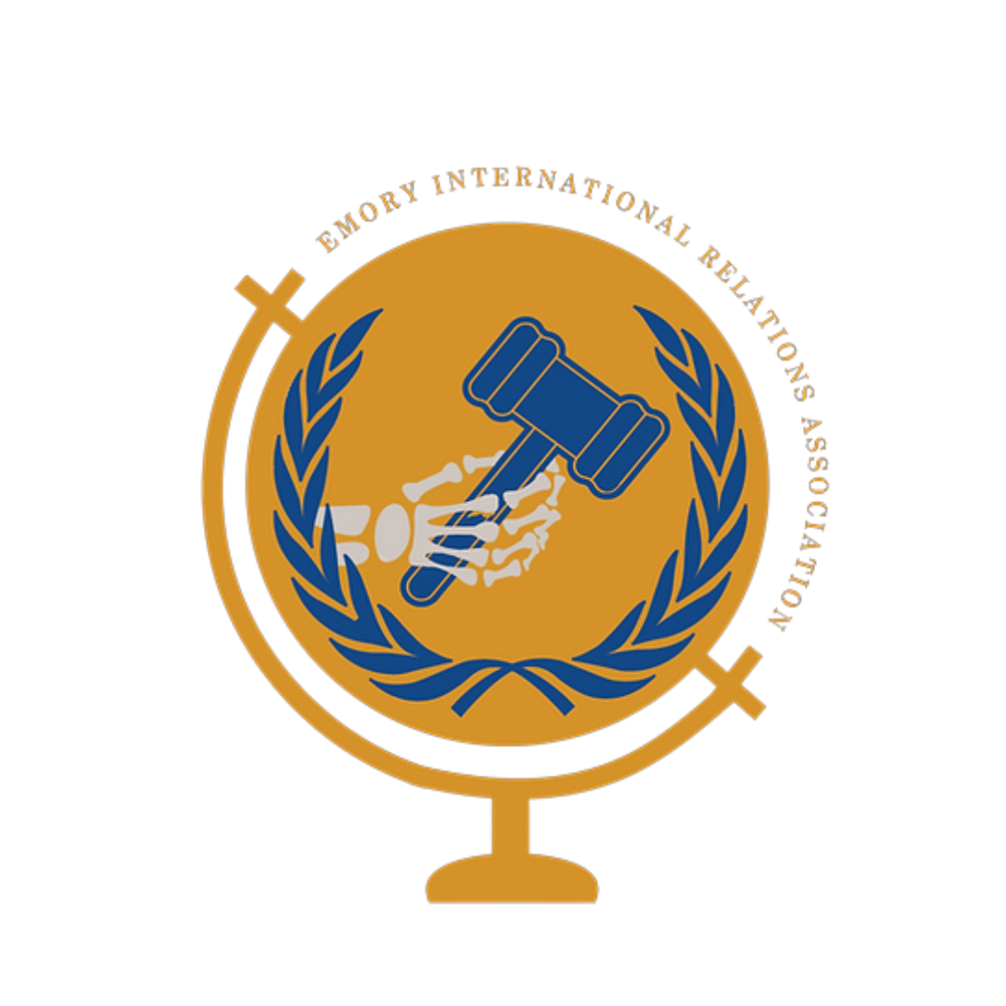
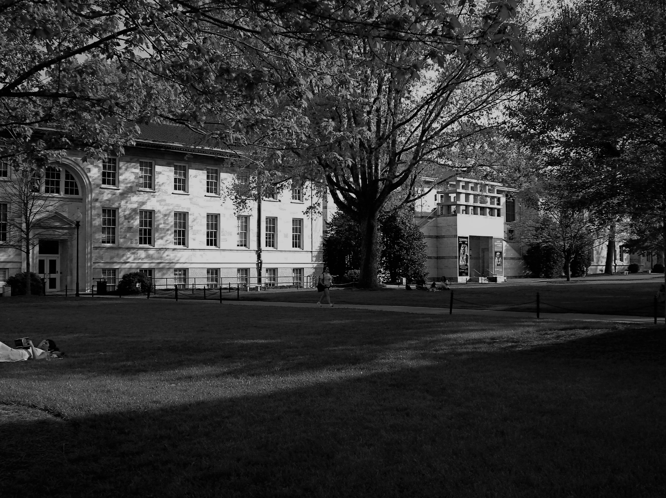

ENMUNC III

November 5th –6th 2022
Emory University

Table of Contents

Letter from the Crisis Director 3

The General Assembly 5

Committee Structure and Dynamics 7
Background Information 9
Current Developments 17

Questions to Consider 22

References 23

Letter from the Crisis Director
Honorable Delegates,
My name is Kara Swain and it is my pleasure to welcome you to DISEC: Ukraine v. Russian Federation. I am a third-year Emory student pursuing my BBA and double majoring in International Studies. Born in Houston, Texas, my passion for Model UN began at high school conferences like ENMUNC, and I am so thrilled to welcome you all to our campus in-person for the first time in ENMUNC’s history! I’m an active member of EIRA, serving as Head Delegate of our top-30 travel team and travelling across the country to compete in conferences just like this one. That being said, being a Chair is my favorite Model United Nations role and I am thrilled to see how this committee will play out.
This year’s edition of ENMUNC puts an emphasis on the Sustainable Development Goals that were developed by the United Nations. The goals were set in 2015 create a pathway for humanity to follow so that we can create the atmosphere for “peace and prosperity for people and the planet, now and into the future.” Throughout our sessions, we will be approaching our topics through the lens of one of the SDGs: Peace, Justice and Strong Institutions. It is important for us to consider questions such as “How does the Russian and Ukrainian conflict threaten the peace in Europe?” and “As an institution that strives to establish peace between nations countries, how can the United Nations approach the conflict while being fair and strong?” We will seek to find answers to those questions and hence “strengthen the bones of society”,
The topic of the current Ruso-Ukrainian conflict is both historic and timely, and before I conclude my introduction, I will comment that delegates should treat this topic with the research and care that it requires. When thousands of lives are at risk in the present-day, this committee is not the time nor setting for lighthearted, humorous resolutions. I have full confidence that your positions and recommendations will be well-researched, as this background guide is far from exhaustive on the topic.
My intentions are to have an engaging and delegate-driven committee, and I want to emphasize that the committee is accessible to delegates may have never competed in a Model United Nations conference before. I will make myself available to help clarify points on parliamentary or any other questions you may have. I hope that ENMUNC will be a great experience for you to develop your MUN skills, improve yourselves as the citizens of the world and create a network of delegates and hopefully, close friends. If you have any further questions or concerns, please feel free to email me at kkswain@emory.edu. I am very much looking forward to meeting you and hearing your ideas and solutions.
Cor prudentis possidebit scientiam,
Kara Swain
The General Assembly

This committee will be a simulation of the First Committee of the United Nations, Disarmament and International Security Committee (DISEC). DISEC focuses on “global challenges and threats to peace that affect the international community”. It also sets to strengthen international stability by encouraging disarmament. In this simulation, delegates will act as members of DISEC to address the specific topic of the Ukraine v. Russian Federation Conflict, with the aim of maintaining international peace and security.
While one of the key principles of DISEC is the regulation of armaments (and should be discussed according to your own discretion), do not center all discussion on arms — your role should be finding any possible methods to ensure international stability through cooperative international discussion.
The end-goal of a General Assembly committee is a resolution. In this specific case, we understand (and encourage) if multiple resolutions are presented. To understand the powers of the committee, and thus what can be included as a recommendation in a resolution, delegates should study Chapters IV of the UN Charter carefully, which establishes the committees’ procedures regarding a variety of situations.
It is critical to discuss the reality of this conflict because it has long lasting impacts on our domestic policies and foreign relations. However, because it is ideologically divisive, some beliefs could be interpreted as offensive. Delegates will be expected to accurately represent the policies of their assigned countries, but I want to reiterate that we will not tolerate outright inappropriate behavior — diplomacy is expected of everyone regardless of personal beliefs. If there is ever an issue and you deem any behavior questionable, we have a process in place to take care of that so please reach out to me if that situation arises in committee.

Committee Structure and Dynamics

This will be a double-delegation committee that flows through moderated and unmoderated caucuses.
Disruptiveness of moderated caucuses will be determined by two tiered factors: total caucus time, followed by number of speakers. For instance, a 10-minute moderated caucus will always be deemed more disruptive than a 9-minute moderated caucus. A 10-minute moderated caucus with 30 seconds speaking time will be more disruptive than a 10-minute moderated caucus with 1 minute speaking time. Motions will be voted in the order of most to least disruptive. In the case that two motions on the table are equally disruptive, then they will be voted in the order in which they were introduced.
Since electronic devices will only be permitted during informal or unmoderated caucuses for drafting working papers and resolutions, the Chair will allow delegates to bring binders with research to support their solutions and arguments for debate throughout the weekend. However, any delegate with a pre-written resolution will be immediately disqualified from any awards or recognition because it defeats the purpose of debate and consensus on the issue. Therefore, if a solution is not brought up previously during a moderated or unmoderated caucus, it will not be allowed on a resolution.

Success in this committee is determined by a couple key variables:
• The delegate’s ability to articulate well-informed opinions on the issues and lobby support to lead the cause they consider essential. No single perspective should completely take over the room as long as every part is committed to pursuing their interests.
• Research is critical. Without a comprehensive understanding of the topics at hand, the past UN actions related to the topic (beyond those in this Guide), bloc positions, among others, delegates will not succeed in the committee.
• Diplomacy is vital too. This means making a real attempt at negotiation and consensus building. The most disappointing outcome of this committee would be a single resolution that was unanimous and “committee-authored” since day one. Polarizing ideologies and interests are represented in the membership of the committee, and a realistic expectation is to come prepared for it. The Chair will not push for a resolution to be passed for the sake of it being passed.
• Respect and decorum preside over all else. A delegate that is disrespectful” toward other delegates will not be tolerated or considered for awards.

Background Information

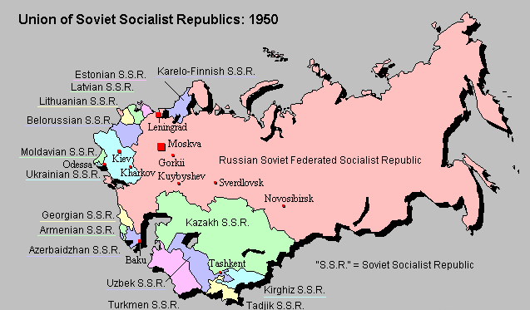
During the February Revolution in 1917, Ukraine announced that they would be fighting against any activity against the government by the Bolsheviks. The people of Ukraine formed “Rada” essentially an assembly of citizens and declared the formation of Ukrainian People’s Republic: an autonomous state, separated from the Russian Republic. After a brief period, the Kievan Bolsheviks announced the declaration of Ukrainian People’s Republic of Soviets and declared war on Rada and its supporters. In response Rada declared independence and started the Ukrainian War of Independence which triggered the invasion of Ukraine by the Bolsheviks troops from Russia. The war between Russia (Bolsheviks) and Ukrainian People’s Republic lasted from 1917 to 1922 and saw the involvement of outer forces like Germany, Poland and Austrian Hungarian Empire. At the end of the war, in 1922, Ukraine became one of the constituent republics that formed the Union of Soviet Socialist Republics (USSR) alongside Russia SFSR, Belarus SSR and Transcaucasian SFSR.

Ukraine was seen as an integral part of the USSR's economy, military and defense industries. Also, Ukraine SSR played an important role for political power within the Union. In 1991, Ukraine voted to be independent from the Union in a referendum and soon after the Soviet Union dissolution happened. Even though Ukraine was expected to be one of the strongest former Soviet Republics, it experienced a devastating recession during the 90s. Ukraine also dealt heavily with state building and forming international relations with other countries especially with the ones in Europe. The state-building during this period focused on establishing an army and governmental institutions. This period, also saw Ukraine pronouncing itself as a European country while establishing ties with the West
The post-independence period for Ukraine strained the already complicated Ukraine and Russian relations. One of the key issues was the Commonwealth of Independent States (CIS). Following the dissolution of the Soviet Union, the CIS was formed to encourage trade, form political and militaristic ties and strengthen the security of the region within the former Soviet Union republics. Although, Ukraine was one of the founding states, it did not ratify the CIS charter that would make them an official member of the Commonwealth. Ukraine saw the heavy involvement with the Commonwealth as a way to integrate all countries under Russia and declined to become an official member. Until the annexation of Crimea by Russia in 2014, Ukraine participated in the meetings of the Commonwealth. After the annexation and the military intervention, Ukraine introduced some bills in its parliament to withdraw from the Creation Agreement. Even though the bills did not pass, and a formal withdrawal was not sent to the Commonwealth Secretary, Ukraine no longer participates in the meetings.
Another important issue was nuclear disarmament. During the reign of the Soviet Union, Ukraine was a popular location for nuclear energy and nuclear armament. The dismay towards nuclear power that enlarged with the Chernobyl disaster continued to grow in the post-independence period. After the dissolution, Ukraine transferred more than half of its nuclear arsenal to Russia; however, this raised another question. Was it wise to hand out these important nuclear weapons and energy to a country that might pose a threat to Ukraine? For a brief period, Ukraine followed a policy that would ensure that their security will be guaranteed and had a nuclear-friendly approach, which caused them to be portrayed as aggressive in the Western media. Ukraine started to receive political pressure from Western countries especially from the United States and in 1992, Ukraine signed the Lisbon Protocol for disarmament.
Perhaps, the most important issue before the recent invasion in Ukrainian and Russian relations was the issue of Crimea: an autonomous republic residing in a strategic location between the Black Sea and the Sea of Azov. While the history of Crimea dates back to 1000 BCE, a turning point for the region was the signing of the Treaty of Küçük Kaynarca between the Russian and Ottoman Empire. Before the treaty, Crimea was a vassal state of the Ottoman Empire however, the treaty established the region as an independent Crimean Tatar State. Nearly ten years later, Catherine II of Russia annexed the region and Crimea became a Russian territory. Even then, the political standing of the region was not established, and Crimean War brought Russia and the Ottoman Empire face to face once again. The war caused many Crimean Tatars to leave their homes and seek shelter in other parts of Russia. With the Russian Revolution of 1917, remaining Crimean Tatars announced their independence. After the Russian Civil War (1918-1920) the region became a part of the Soviet Union as the Crimean Autonomous Soviet Socialist Republic (Crimean ASSR) in 1921. Crimea witnessed one of the biggest minority oppressions of its history with the deportation of Crimean Tatars (nearly 200000) from Crimea to Siberia for their alleged collaboration with the Nazis during World War II. After World War II, Crimea became a region of the Russian Soviet Federated Socialist Republic, (Russian SFSR) later to be given to Ukraine. During the 80s and 90s, many Crimean Tatars resettled in the region and in 1991, Crimea once again became an autonomous republic within the Soviet Union. However, with the dissolution of the Soviet Union that year, the autonomy was short-lived, and Crimea became a part of the independent Ukraine. In 1994, Ukraine, Russia, the United Kingdom and the United States signed the Budapest Memorandum that established Ukraine’s borders to be the same as the pre-Soviet Union times, transfer of nuclear weapons and facilities from Ukraine to Russia and extending Russia’s usage of Sevastopol port for its fleet. In addition, Crimea was affirmed to be included as a Ukrainian territory.
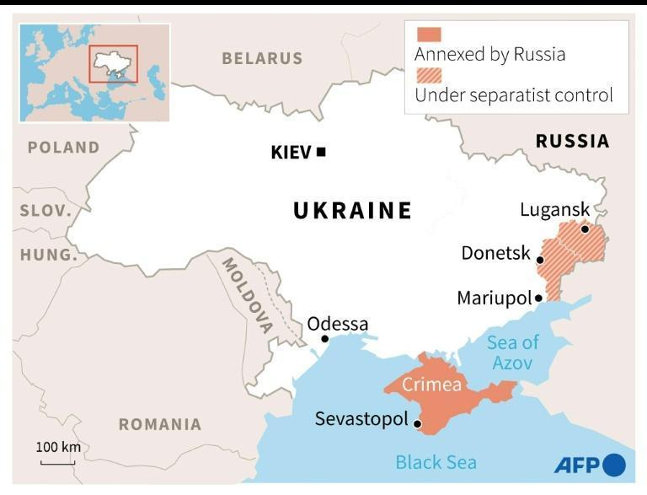
In 2010, to the dismay of his citizens the president of Ukraine allowed the presence of Russia on Sevastopol until 2042 and allowed them to have 25.000 troops at Sevastopol with air bases in Crimea. In 2014, the president fled the country and protests against these decisions erupted. During the protests the Crimean parliament building was seized by the Russian troops according to a later identification. Pro-Russian parliament members chose a new prime minister from the Russian Unity Party who had received less than 5% of the votes in the previous election. Later that year, the parliament sent a request to Russian president Vladimir Putin to send their army to protect the ethnic Russian population against the protests that were being held by Ukrainians and Crimean Tatars. Later, the Parliament voted unanimously to leave Ukraine and join Russia. A referendum was held in March 2014 and the results were 97% in favor of joining Russia; however, Ukraine didn’t recognize the referendum as official. It was later estimated that the turn out rate for this referendum was approximately 30% percent. Majority of the international community saw this as an illegal annexation and the United Nations emphasized the importance of having Crimea as a part of Ukraine. After the annexation of Crimea, Russian troops engaged in open warfare in eastern Ukraine territories. In 2018, Russia opened the bridge that united Russia and Crimea directly and Russia increased its naval presence within the region.
Crimea is also a region that consists of people from many different ethnic backgrounds. While the region is predominantly Russian, Ukrainians, Crimean Tatars, Belarussians, Armenians and other ethnic groups also inhabit the region. This rich ethnic make-up of Crimea enriches the region while raising questions on ethnic and racial discrimination. Historically, Crimean Tatars have been the predominant ethnicity in the region however, with their deportation during Stalin’s reign and many of them losing their lives during the process, their numbers fell.
According to a 2001 census, Crimean Tatars make up 12.1 percent, while Ukrainians make up 24.3 percent and Russians make up 58.3 percent of the population.
The annexation of Crimea by the Russian Federation in 2014, worsened the situation for ethnical minority groups. According to a European Union Research, since the annexation of the region “documented violations have occurred in the areas of freedom of expression, conscience, and religion; the right to peaceful assembly and association; freedom of the media and access to information; the right to a fair trial and effective remedy; the right to education in one’s native language; and linguistic and cultural rights.” De facto authorities have been targeting pro-Ukraine Crimeans and harsh measures like unwarranted searches, seizures, arrests, and murders have been put in place. From 2014 to 2016, it is estimated that over 21000 Crimeans have fled to Ukraine because of the oppression. The political parties and media are also at risk and their activities are being limited. The de facto authorities ordered the re-registration of media outlets and refused to give permits to media outlets that were popular among minority groups. They also restricted the broadcast of Ukrainian channels in the region and interfered in many public protests and detained protestors. In schools, Russian was encouraged as the primary language and Ukrainian books and classes were restricted. Ukrainian cinemas, libraries and museums were closed. The usage of Crimean Tatars’ language has also declined, and hours of classes were dropped. Finally, acquiring Russian citizenship is technically forced on the citizens since one cannot access education, working permits, owning properties and healthcare services without a Russian citizenship.

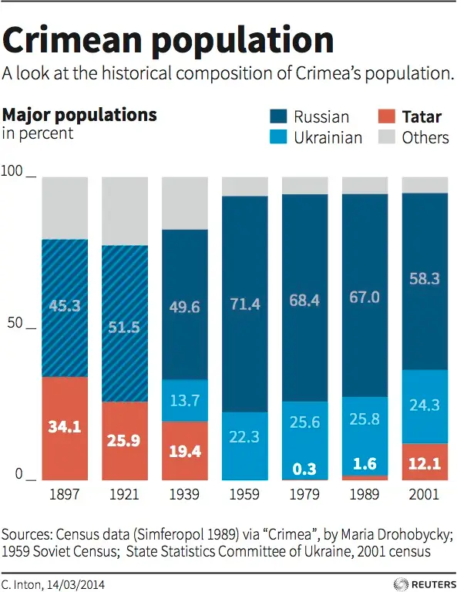

Current Developments
The period from the beginning of the conflict in early 2014 until the implementations of Minsk-I (a.k.a Minsk Protocol in September 2014) and Minsk-II (February 2015) truces can be identified as the intense phase of the conflict with hundreds of dead and thousands of wounded in a matter of months. The Minsk-II ceasefire agreement has been violated by both sides hundreds of times.

Timeline to the Invasion:
Just after the ceasefire talks in December 2015, there was a concentrated cyber offensive against Ukrainian power grids which left thousands without electricity. The year 2016 saw no escalation or de-escalation in armed conflict until September 2016, when another ceasefire was agreed on. It is considered the most successful ceasefire which resulted in a few consecutive weeks without active fighting. In 2017 though the conflict erupted once more into a myriad of skirmishes and failed ceasefire attempts, the casualties on both sides were not as severe as they were back in 2014 and 2015. There were also a large series of cyber attacks against Ukraine in March (WannaCry ransomware attack) and in June. The fighting intensified throughout 2017 and 2018 because of the second wave of reinforcements from Russia to the so-called Novorossiya (the area controlled by pro-Russian separatist groups) and saw major battles like the battle of Adviivka and the death of Alexander Zakharchenko, the leader of Donetsk People’s Republic. From March 2019 until October 2019 the fighting died down thanks to extensive negotiations between Ukraine, Luhansk People’s Republic, Donetsk People’s Republic, Russian Federations, and the OSCE. These negotiations aimed to fulfill the articles of the Minsk-II Agreement like bilateral withdrawal of troops and heavy equipment, OSCE-monitored referendums in DPR and LPR et cetera. In November 2019 both sides successfully withdrew their equipment and soldiers in accordance with the last ceasefire agreement, and in the following December, warring parties entered “Normandy format” peace negotiations in Paris, which resulted in a successful exchange of prisoners of war and scheduling of future talks.
In 2020, the outbreak of the Covid-19 pandemic affected the war-torn Donbas gravely, and Ukraine, DPR, LPR, and Russia all implemented quarantines to fight off the virus. This directly affected the frontlines as borders were closed because of the quarantines, which meant the end of the material flow into Novorossiya from Russia. Thus the year 2020 became the most peaceful year of the conflict with Ukrainian casualties only amounting to a total of 50 deaths. However, with widespread vaccinations in Russia, Novorossiya, and Ukraine material flow to both parties resumed from where it stopped in 2020. In March, April, and May of 2021 the military activity of Russia especially increased dramatically. Increased drills began in Voronezh and Rostov Oblasts (provinces), in which more than 100000 Russian soldiers are amassed on the Ukrainian border, and according to the Ukrainian border guard, the number of Russian soldiers in Crimea increased to 85000 in early April. With the resumption of Russian equipment flow from Russian troop movements, the LPR and DPR re-mobilized their troops and began raiding Ukrainian redoubts. By spring of 2021, the skirmishes escalated to whole-front shelling, and tanks and BMP-1 class armored vehicles were used by the pro-Russian side in their raids. As a counter-show of force NATO held one of the largest military exercises in its history, Defender-21 in March 2021. On the diplomatic front, Ukraine tried to accelerate its membership process with NATO, while Russia continuously condemned these efforts as aggressive and threatening.
In August 2021 the Ukrainian president called on the leaders of the Western countries that Crimea must be reclaimed by Ukraine in an international summit in Kyiv. In September 2021 Ukraine and the United States organized joint drills near the Byelorussian border.
From October 2021 to February 2022, Russia implemented its biggest military buildup in Russia and Belarus, but denied any intentions of invasion or attack on Ukraine.
From February 21-23, Russia doubled down on campaigns to promote misinformation. The intention was to justify forceful methods and mute national and international criticism. Within the campaign were allegations of unlawful acts from Ukrainians “saboteurs” crossing the border into Russia. Ukraine and the Western media took this as a pretext for initiating war.
In February 24 of 2022, Russia invaded Ukraine through the ground and
attacked Ukrainian cities through the air. Russian president Vladimir Putin
announced it as a “special military operation for demilitarizing Ukraine”. What
followed is the largest refugee crisis since World War II.
Since, thousands and thousands have (very likely) died and around 8 million
have fled or been displaced. These numbers pertain to both sides.
Internationally, many countries have imposed sanctions and condemned the
invasion. Moreover, more than 1000 companies have left both Russia and Belarus.
The Council of Europe expelled Russia, The International Court of Justice ordered

Russia to stop the invasion, and finally, 176 nations — through the United

Nations General Assembly — laid their stance on the conflict.

Note About Committee Timeline:

It will be your role as delegates to represent your nation accurately; Since

this is an ongoing conflict, to succeed in committee you must investigate

specifically how your position responds to the conflict until the day the conference

starts — November 5. All information present until that day could be used

in committee.

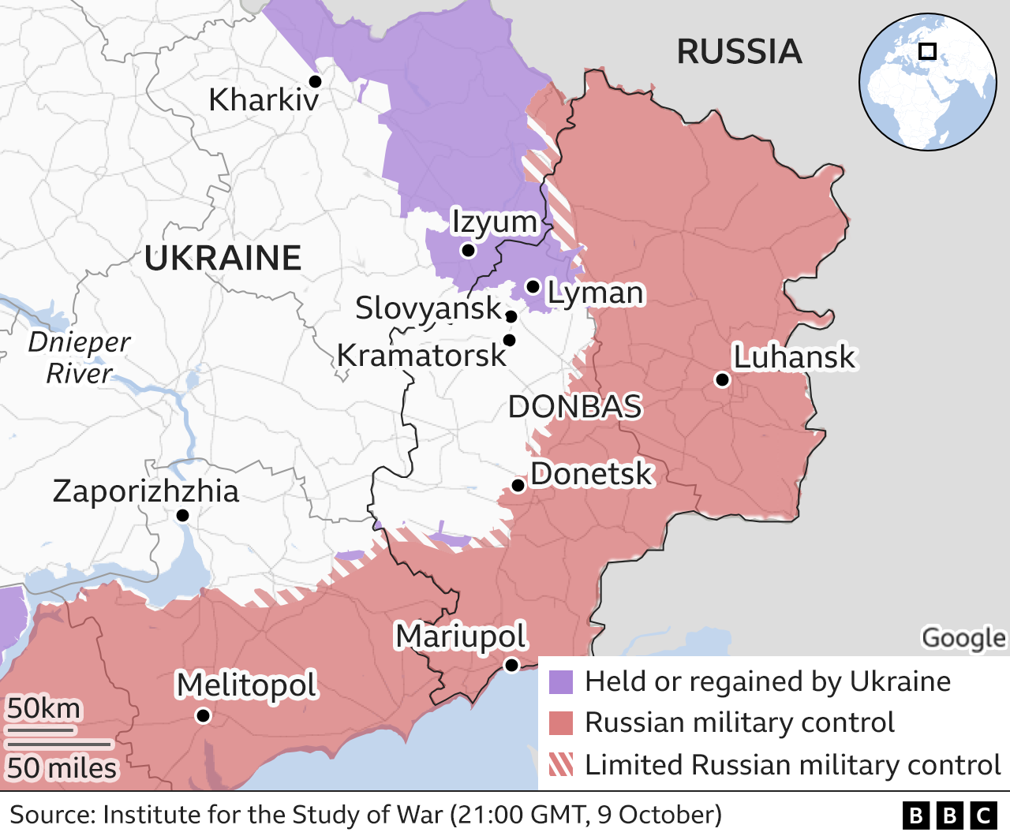

Questions to Consider

- How can this committee peacefully resolve the current conflict in Ukraine with the least possible humanitarian impact?

- How should the United Nations honor the sovereignty of nations while balancing international peace?

- What is the best way to provide repercussions on the nation-state of Russia for invading Ukraine?

- What solutions should be pursued in the short term to stop the conflict? What about the long term? How will these solutions be implemented?

- How can other member states of the United Nations provide support to the conflict? Are there any states with countervailing interests?

- How should the United Nations provide humanitarian support and aid to refugees and victims of the conflict?

- Should the world be worried about further escalation of the conflict? How can it be prevented?

- Is there a precedent from which you can base yourself to make decisions?
- What will be repercussions of the decisions you make in committee? Are you creating a precedent for how the UN will act in future scenarios?

References
BBC. (2015, February 12). Ukraine ceasefire: New MINSK Agreement key points. BBC News. from https://www.bbc.com/news/world-europe-31436513.
Council on Foreign Relations. (n.d.). Conflict in Ukraine | Global Conflict Tracker. Council on Foreign Relations, from https://www.cfr.org/global-conflict-tracker/conflict/conflict-ukraine.
Herszenhorn, D. M. (2021, August 23). Crimea summit a reminder: The West Hasn't Undone Russian annexation. POLITICO. from https://www.politico.eu/article/summit-crimea-highlights-wests-failure-reverse-russian-annexation/.
International convention on the elimination of all forms of racial discrimination. OHCHR. (n.d.). from https://www.ohchr.org/en/professionalinterest/pages/cerd.aspx.
Latest developments: Application of the International convention for the suppression of the financing of terrorism and of the International Convention on the elimination of all forms of racial Discrimination (ukraine v. Russian federation): International Court of justice. Latest developments | Application of the International Convention for the Suppression of the Financing of Terrorism and of the International Convention on the Elimination of All Forms of Racial Discrimination (Ukraine v. Russian Federation) | International Court of Justice. (n.d.), from https://www.icj-cij.org/en/case/166.
Oliphant, R. (2017, March 6). Ukraine sues Russia in International Court of justice FOR 'financing terrorism'. The Telegraph. Retrieved from https://www.telegraph.co.uk/news/2017/03/06/ukraine-sues-russia-international-court-justiceforfinancing/.
United Nations High Commissioner for Refugees. (n.d.). International convention for the suppression of the financing of terrorism. Refworld. from https://www.refworld.org/docid/3dda0b867.html.
United Nations. (n.d.). International convention for the suppression of the financing of terrorism. United Nations. Retrieved from https://www.un.org/law/cod/finterr.htm.

