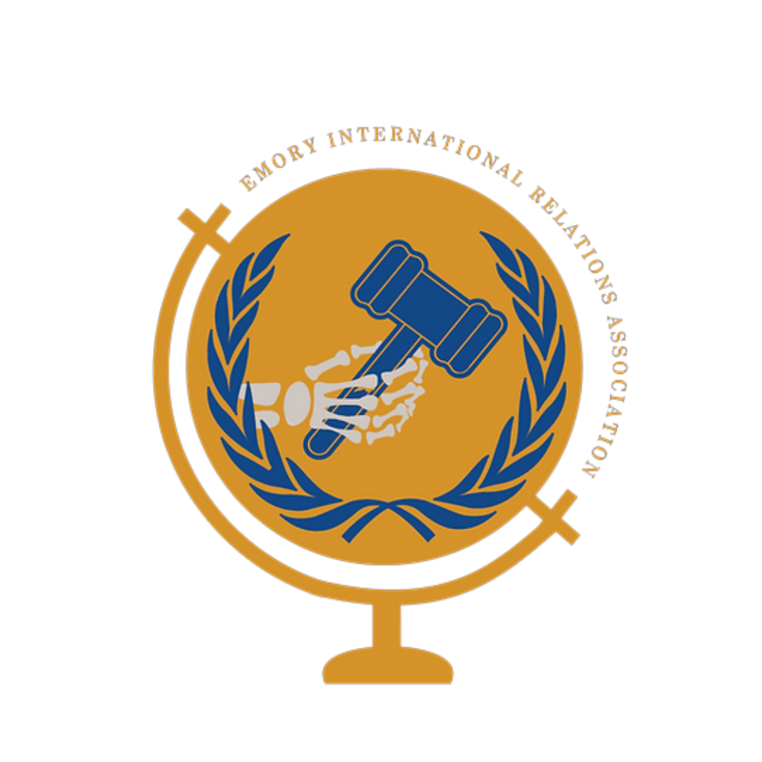
W
COMMITTEE BACKGROUND GUIDE

The Climate Crisis
Crisis Director: Chaeyeon Lim

W
W
W

W
W
W
W

W
W
W

W
W

W
W
W

W
W
W

W
W
W

W
W

W
W
W

W
ENMUNC III

November 5th –6th 2022
Emory University
W
W
W

W
W
W
Table of Contents

Welcome Letter 3

The General Assembly 4

Committee Setting and Introduction 5

Background 7

Potential Solution 11

Important Terms and Concepts 13

Countries 16

References 21

Welcome Letter
Dear Delegates,

Welcome to Emory’s third annual high school Model United Nations conference, ENMUNC! My name is Chaeyeon Lim, and it is my pleasure to serve you as your chair for our first General Assembly: Climate Crisis. I am a sophomore at Emory University majoring in psychology. I am originally from Seoul, South Korea, and I am attending Emory as an international student. This will be my first time chairing for Emory, and my eighth conference since my high school MUN journey.
I believe the General Assembly is not only a great place to start but also to come back to the formal basics. This year’s topic will be climate change - I’m sure everyone has at least one experience that has indirectly or directly influenced their life - that has been around the news for quite a while. Recent weather-related disasters: flooding, droughts, heatwaves, volcanic eruptions, and hurricanes, including the recent hurricane Fiona and Ian that hit the US, are all consequences of climate change caused by human activities. Our committee will be discussing measures to combat climate change in a way that is unique from previously cliche and endless new solutions - instead proposing feasible solutions to bring action immediately.
At the end of the day, I wish delegates would appreciate the importance of Earth and the urgency of climate change, and also have enjoyed the Model UN experience. I look forward to meeting all of you!

Yours sincerely,
Chaeyeon Lim
chaeyeon.lim@emory.edu

The General Assembly
The end-goal of a General Assembly committee is a resolution. In this specific case, we understand if multiple resolutions are presented. To understand the powers of the committee, and thus what can be included as a recommendation in a resolution, delegates should study Chapters IV of the UN Charter carefully, which establishes the committees’ procedures regarding a variety of situations.

Delegates will be expected to accurately represent the policies of their assigned countries, but we want to reiterate that we will not tolerate outright inappropriate behavior or comments — diplomacy is expected of everyone regardless of personal beliefs. If there is ever an issue and you deem any behavior questionable, we have a process in place to take care of that so please reach out to me if that situation arises in committee.

Committee Setting and Introduction
This General Assembly will take place in modern settings - 2022 - considering all ongoing climate hazards and outbreaks. Your goal as delegates is to confront past, present, and future climate challenges. Your resolutions must address the following three aspects: preventing future climate crises, developing protocols to take immediate action, and recovering from existing damage.
In this climate crisis committee, rather than proposing fancy impractical ideas, we will be centering on realistically implementing solutions to deduce observable, efficient outcomes to combating climate crisis. Key concepts to focus are climate resilience, feasibility, and community-based adaptations. We acknowledge there are more than enough mitigation and adaption tools to combat the climate crisis issue, however, the question is: are they actually happening? It is challenging to put proposals into action and normalizing the new systems, hence the committee will be focusing on localizing and specifying solutions considering various climate circumstances.

Success in committee will be determined by a couple key variables:

• The delegate’s ability to articulate well-informed opinions on the issues and lobby support to lead the cause they consider essential. No single perspective should completely take over the room as long as every part is committed to pursuing their interests.
• Research is critical. Without a comprehensive understanding of the topics at hand, the past UN actions related to the topic (beyond those in this Guide), bloc positions, among others, delegates will not succeed in the committee.
• Diplomacy is vital too. This means making a real attempt at negotiation and consensus building. A disappointing outcome of this committee would be a single resolution that was unanimous and “committee-authored” since day one. Polarizing ideologies and interests are represented in the membership of the committee, and a realistic expectation is to come prepared for it. The Chair will not push for a resolution to be passed for the sake of it being passed.

Background
It is common knowledge to all that climate change and global warming are happening right now - but perhaps somewhere around the world that is probably not where we’re at. Somewhere that isn’t a city, but rather an unnamed suburb that treats things like this as usual.

The fact is that statement could not be farther from the truth: the climate crisis is no longer a regional issue but a worldwide one.

The Greenhouse Gas Effect and Climate Change

Current climate change is all about the enhanced greenhouse gas effect. The greenhouse gas effect refers to the phenomenon of atmospheric ozone (greenhouse gases) absorbing the infrared radiation from the Sun. The heating results from these ozone gases emitting energy after their absorption and returning some heat back to the Earth’s surface. This is a natural process that is essential in maintaining Earth’s temperature to sustain living organisms and processes. However, an enhanced greenhouse gas effect is problematic from the excessive production of greenhouse gases (mainly Carbon Dioxide and Methane) from human activities.
The 2022 CO2 level on Earth recently peaked at 421ppm (parts per million) compared to last year’s concentration of 417ppm. The present value is 50% higher than the pre-industrial levels (until the late 1800s to early 1900s) of 280 ppm. This was consistent for the 6,000 years of human civilization until the industrial revolution overturned our lives for the last 200 years.
Increased CO2 levels, a major greenhouse gas, signify that the Earth’s temperature has also increased. Our Summer 2022 temperature was the sixth highest for August in the past 143-year record, with all 10 warmest Augusts occurring in the recent 13 years since 2009. (August 2022 Global Climate Report) The damage done on Earth is worse in the recent 20 years than that of the past thousands and millions of years - the 21st century has the largest increase in temperature than any other century in the past 1,000 years. Although the current interglacial period isn’t the warmest on record, we do have the highest CO2 and greenhouse gas emissions.
Changes in climate will result in severe consequences in all weather, land, and ocean. There will be more tornado outbreaks with stronger hurricanes, with unexpected intervals. With warmer oceans, the rate of evaporation increases, producing higher land precipitation, such as intense and frequent snowstorms and rainfalls. Ice sheets melt and sea levels rise, destroying biodiversity and human civilization around the coastlines. More than 10% of the world’s population lives in LECZs (Low Elevation Coastal Zones), which are extremely vulnerable to flooding and erosions. These not only influence direct life near land but also impact resources and supply exported from water, agricultural yields and demands, and even outbreak of water-related diseases.

History and Timeline of Events

Industrial Revolution (1760 - 1840)
This period was the introduction of machinery, new technology, and mass production, initiated by the United Kingdom. The world continues to follow this style of the manufacturing process and is now one of the largest causes of abnormal climate change and enhanced greenhouse gas effects. CO2 levels before the industrial revolution (pre-industrial levels) was approximately 280ppm.

UN Framework Convention on Climate Change (1992)
This was the first establishment of an international treaty to combat “dangerous human interference with the climate system”.

Kyoto Protocol to the UNFCCC (1997)
The Kyoto Protocol Agreement proposed emission reduction requirements for 2009-2012, insisting on going back to the 1990 CO2 levels. This agreement was signed by 60 countries, with most being developed countries.

The Cancun Agreement / Copenhagen Accord (2010)
The Cancun Agreement’s goal was to hold down the warming by 2ºC with a reduction pledge for 2020. Because this was not required to sign or ratify, the expectations are not legally binding. A huge loophole is that this agreement does not specify relative targets, such as the Paris Agreement’s goals relative to pre-industrial levels.
The agreement divided countries into Annex I and non-Annex I nations. Annex I nations are typically industrialized countries (such as the OECD members). The non-Annex I nations are developing countries that will target for mitigating their status quo.

The Paris Agreement (2015)
The 2015 Paris Agreement’s goal is to hold down the warming by 2ºC or, most ideally, 1.5ºC compared to pre-industrial levels (UNFCCC Progress). 193 parties have joined the agreement. The agreement insists on 1) limiting temperature, 2) reviewing countries’ commitments every five years (updating their own Nationally Determined Contribution (NDC) action plan), and 3) providing financial aid to developing countries. However, there aren’t any measures to enforce the countries to meet these expectations in this agreement.

Potential Solutions
Providing solutions for the climate crisis is a difficult task, as it is an extremely broad and multifaceted issue that stretches out to every field of human civilization. There are two approaches to potential solutions: Mitigation and Adaptation.
The mitigation approach is known as “avoiding the unmanageable.” This is what would be ideal to prevent further escalation of the climate crisis and reduce risk factors. The goal of mitigating the status quo would be reducing emissions and modifying contemporary industrialization systems.
Measures to decarbonize our energy systems include using renewable energy and nuclear gas, employing electric transportation systems, and developing low-cost, cost-efficient energy and battery technologies. Geoengineering technology is also an option to counteract climate, often referred to from current climate policies. However, these are time-consuming and ongoing projects that sound superficial with lacking detail that produce no tangible results.
All these decarbonizing practices should only be our first step - these should never be our final destination. It is extremely important to remember that it is not the committee or delegates’ job to research environmentally effective measures, but rather to debate the feasible and realistic aspects of implementing these measures scientists are working on. Consider the management stages of distributing and practicing these systems - the time, cost and investments, security, popularity, universality, potential, and more.
The adaptation approach is known as “managing the unavoidable.” Methods include developing detailed guidelines and building infrastructure resilient to climate change. We must understand that climate resilience minimizes the risk factors, not fully eliminating them.
One important aspect of this debate should be maintaining the balance between risk minimization and cost. Another key point is to recognize that infrastructures don’t work on their own - their interactions with the regional circumstances, such as exposure and vulnerability that vary among countries, are significant. (Climate-Resilient Infrastructure, OECD 2018) To ensure that these ideas are properly implemented in all countries, we must consider that these infrastructures agree with the country’s existing policies and norms.
Do the proposals suit the country’s specific needs? Or Are they generic and do not address proper issues? The debate between replacement/update and expansions/introduction remains unresolved among developed and developing countries. Lastly, discussion of the aftermath of these infrastructures is important - how will they be treated once they are built and installed? How will they actually be implemented within the community? How will these infrastructures effectively protect and interact with people on a daily basis?

Important Terms and Concepts

Pre-Industrial Levels
Pre-industrial levels refers to the statistics (average global temperature, carbon dioxide emissions, etc) before the industrial revolution.

Cooperation of the Parties (COP)
COP is the decision-making body responsible for monitoring countries’ implementations of UNFCCC resolutions. It is their job to review the NDCs submitted by countries and the efficacy of the measures to achieving the objective of UNFCCC.

Nationally Determined Contribution (NDC)
Nationally Determined Contribution is an official report submitted by all countries in the Paris Agreement to update their progress and policies on achieving the goal.

Carbon Sinks
Carbon Sinks refer to environmental resources (forests, oceans, etc) that can be used to remove or absorb the greenhouse gases emitted to the atmosphere.

Carbon Neutrality
Carbon Neutrality means to work towards removing equivalent amounts of carbon dioxide as much as they are emitted to the atmosphere.

Net-Zero
Net-Zero expands beyond carbon neutrality, and works with all greenhouse gases. They intend to remove all greenhouse gases emitted by human activity from the atmosphere.

Extreme Weather Events
Extreme Weather Events are different from natural disasters. They are events that are rare at the specific time and place of the year.

Natural Disasters
Natural Disasters are hazardous, destructive events that result in severe consequences in a community that harms the society’s normal functioning.

Greenhouse Gas
Greenhouse gases are natural gases that constitute the ozone layers surrounding the Earth’s atmosphere. These gases have the ability to trap heat emitted by Earth and returning some back to the Earth’s surface. Greenhouse gases include carbon dioxide (CO2), water vapor, methane (CH4), and nitrous oxides (N2O). According to the IPCC (Intergovernmental Panel on Climate Change) 2022’s summary, carbon dioxide from fossil fuels and industry contributes the most to the greenhouse gas emission as 64%.

Global Warming
Global Warming is not caused by the natural greenhouse gas effect, but by the enhanced greenhouse effect. Enhanced greenhouse effect are typically due to fossil fuel combustion, increasing carbon dioxide and methane levels.

Carbon Footprints
Carbon footprint is referred to as the amount of carbon emitted by an individual or an organization through any activity.

Climate Resilience
The capacity of social, economic and ecological systems to cope with climatic hazards in a flexible manner to maintain their essential original function.

Community-Based Adaptation
Community-Based Adaptation focuses on the specific climate capacity and potentials of each community. They take context, culture, and preference of communities to implement and design solutions.

Countries

Germany
Germany is an Annex I country and has ratified both the Kyoto Protocol in 2002 of May and the Paris Agreement in October 2016. Germany, as a developed country, is encouraged to take the lead in reaching the emissions targets, provide financial resources to assist developing countries, and make an effort to transparently communicate effective strategies.
Germany’s current contribution to global CO2 emissions is approximately 2.17%. They have established their new Climate Action Plan 2050 in 2016, making them the first few countries to submit their NDC action plan to the United Nations as required by the 2015 Paris Agreement. Their plan aims to become a greenhouse gas-neutral country in order to achieve carbon neutrality as stated by the Paris Agreement. Specifically, they plan to cut down greenhouse gas emissions by a holistic minimum of 55% by 2030, compartmentalizing detailed targets for each sector: energy, industry, buildings, transport, and agriculture.

India
India is non-Annex I country and has ratified both the Kyoto Protocal in 2002 August and the Paris Agreement in 2016 of October.
India’s contribution to current CO2 emissions is approximately 7%, being one of the top three countries that contribute to the world’s emissions. India is also the world’s most populated country, naturally leading to increased consumption of energy. New Delhi, India’s capital city, has experienced extreme heat waves for several weeks, exceeding 40ºC in 2022. They also suffered from cyclones, floods, and heavy rainfalls that destroyed 12 million acres of crops, contributing to sharp peaks in food prices last year.
India’s commitment to the United Nations is considered relatively low, however, their policies within the country remain ambitious for its long-term plans. At the 2021 United Nations climate talks, the prime minister of India announced that India will aim to zero out its greenhouse gas emissions by 2070. In August 2022, India submitted its second NDC plan to the United Nations, which included shorter-term plans by 2030.

Indonesia
Indonesia is a non-Annex I country that has ratified the Kyoto Protocol in 2004 December and the Paris Agreement in October 2016. As a developing country, it is their responsibility to continue with their mitigation effects and expected to expand the targets suited to various national circumstances.
Indonesia contributes approximately 2% of the world’s CO2 emissions, and most come from their burning of fossil fuels. Back in 2021 July, they submitted their NDC plan to the United Nations. Indonesia aims for a net-zero by 2060 with stronger national restrictions, maintaining “business-as-usual” with previous climate policies by 2030. They also appeal for financial support and climate economy as they transition their forestry and energy sectors to environmentally friendly systems.

Mozambique
Mozambique is a non-Annex I party and ratified the Kyoto Protocol in January 2005 and the Paris Agreement in June of 2018.
Mozambique is an extremely vulnerable country and frequently experiences extreme weather events, such as floods, droughts, and cyclones. Because two-thirds of their population live and work in rural areas, it is extremely difficult to protect their land and people from natural disasters. Their top priority is to prevent catastrophic damages and adopt early warning systems for unavoidable natural disasters. Mozambique’s economy heavily relies on its business with agriculture, natural gas, and mineral resources, which make their transition to energy-efficient, environmentally friendly systems particularly difficult. Mozambique needs multifaceted, adaptable solutions that embrace all aspects of the challenges they face, whether that be geographical, financial, or social.

People’s Republic of China
China is a non-Annex I country and ratified the Kyoto Protocol in August of 2002 and the Paris Agreement in September 2016. Although China is classified as a non-Annex I country, it is one of the economically powerful nations that has shown exponential growth patterns in the past decade.
China is responsible for the largest portion of the world’s CO2 emissions, occupying 29% of the total with a steady increasing trend over the years. Like all other countries under the 2015 Paris Agreement, China targets carbon neutralization by 2060. China’s main energy source comes from coal, which burns fossil fuels. Regardless, China has been active in the international community advocating for climate action, also chairing the UN Biodiversity Conference in 2022 to discuss the post-2020 global biodiversity framework (COP 15). Furthermore, China’s updated NDC recognizes the multifaceted nature of climate change and emphasizes responsibilities in establishing an “equitable, mutually beneficial global climate governance system”.

Russia
Russia is an Annex I country that has ratified the Kyoto Protocol in November 2004 and Paris Agreement in April 2016.
Russia, the largest country in the world, contributes approximately 7% to global CO2 emissions, ranking fourth in the world’s contribution. Russia’s NDC emphasizes their 30% emission reduction goal by 2030, support for developing countries, and worldwide implementation of climate adaptation policies (particularly in transportation, fuel/energy, and industrial sectors). While Russia’s greenhouse gas emissions significantly decreased by 30.3% between 1990 and 2018, they increased by 3% in 2018 compared to their previous years. However, this still shows Russia’s capabilities to combat climate change. They also focus on distributing renewable energy sources through cooperation with other developing countries in scientific technology and research.

United States of America
The United States of America is an Annex I country and ratified the Paris Agreement in 2016 of September. However, they did not ratify the Kyoto Protocol concerned with potential economic concerns - it was only signed by Bill Clinton.
The United States of America contributes the second most with 14% to the world’s CO2 emissions. By rejoining the 2015 Paris Agreement in February 2021 by President Joe Biden, they have submitted an updated NDC in April 2021. The White House’s goal states as follows: reducing greenhouse gas emissions 50-52% below 2005 levels by 2030, achieving 100% carbon pollution-free electricity by 2035, reaching a net-zero emissions economy by 2050, and delivering 40% of federal investment benefits to climate and clean energy to disadvantaged communities.

** This is not a list of all countries that will be present in committee. We will have at least 35 different delegations present, but these country summaries in the context of climate change should offer a look into what you, as a delegate, at the very least should know about your assigned country in order to excel in committee. This list should also give you a strong general sense for what all the delegations will look like (I.e. it is a good representation of the whole).

References

Bmuv. “Climate Action Plan 2050 – Germany's Long-Term Low Greenhouse Gas Emission Development Strategy.” BMUV, https://www.bmuv.de/en/topics/climate-adaptation/climate-protection/national-climate-policy/climate-action-plan-2050-germanys-long-term-low-greenhouse-gas-emission-development-strategy.
“Climate-Resilient Infrastructure.” OECD.org, OECD, https://www.oecd.org/environment/cc/policy-perspectives-climate-resilient-infrastructure.pdf.
IPCC, 2022: Summary for Policymakers. In: Climate Change 2022: Mitigation of Climate Change. Contribution of Working Group III to the Sixth Assessment Report of the Intergovernmental Panel on Climate Change [P.R. Shukla, J. Skea, R. Slade, A. Al Khourdajie, R. van Diemen, D. McCollum, M. Pathak, S. Some, P. Vyas, R. Fradera, M. Belkacemi, A. Hasija, G. Lisboa, S. Luz, J. Malley, (eds.)]. Cambridge University Press, Cambridge, UK and New York, NY, USA. doi: 10.1017/9781009157926.001.
NCEI.Monitoring.Info@noaa.gov. “August 2022 Global Climate Report.” August 2022 Global Climate Report | National Centers for Environmental Information (NCEI), https://www.ncei.noaa.gov/access/monitoring/monthly-report/global/202208.
“NDC Registry.” Unfccc.int, https://unfccc.int/NDCREG.
Ritchie, Hannah, et al. “CO2 Emissions.” Our World in Data, 11 May 2020, https://ourworldindata.org/co2-emissions.
Stein, Theo. “Carbon Dioxide Now More than 50% Higher than Pre-Industrial Levels.” National Oceanic and Atmospheric Administration, https://www.noaa.gov/news-release/carbon-dioxide-now-more-than-50-higher-than-pre-industrial-levels.
UNFCCC. “The Paris Agreement.” Unfccc.int, https://unfccc.int/process-and-meetings/the-paris-agreement/the-paris-agreement.

